Civilization Fact Report: Roman Republic and Empire
Chronology. | Map.  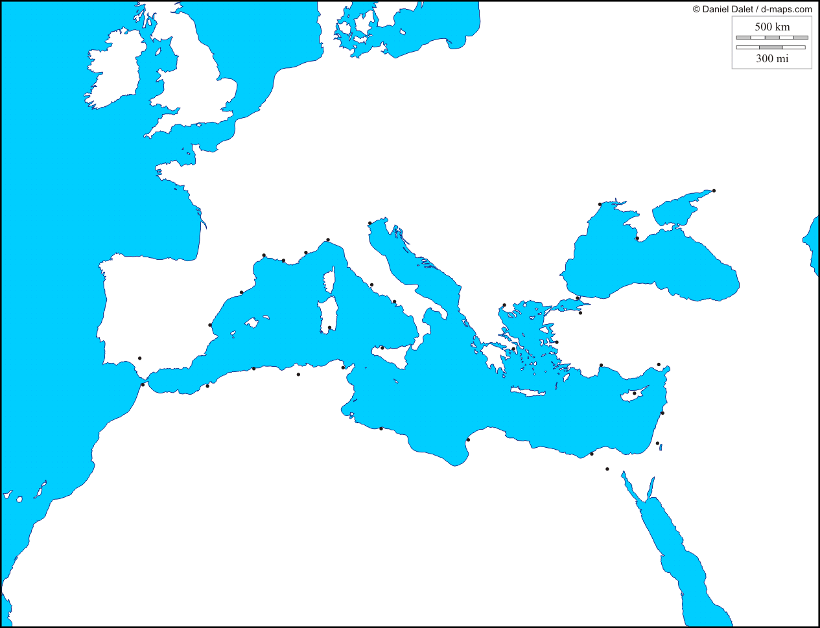

PERSIAN Summary. Put together the Political, Economic, Religious, Social, Interactive, Artistic, & Natural characteristics. This should be FULL of names, dates, key terms, & other historic evidence! Key Terms for the Roman Republic and Empire: Etruscans, federation, republic, res publica, Augustus, Senate, patricians, plebians, General Assembly, consuls, tribunes, Julius Caesar, Triumverate, Octavian, Antony, Cleopatra, Actium, Augustus Caesar, princeps, equites, Law of the Twelve Tables, Pax Romana, patron-client relationship, Roman roads, legions, paterfamilias, Roman Forum, Punic Wars, Carthage, 3rd century crisis, 4 Legal Principles, Virgil, The Aeneid, Livy, Germanic Tribes, Diocletian, Constantine, Constantinople, Visigoths, Jupiter, Mars, Minerva, Venus, Christianity, Jesus, Peter, Paul, Vatican, Edict of Milan, Theodosius
Political: Thesis sentence:

Economic: Thesis sentence:

Religious/Philosophical: Thesis sentence:

Social: Thesis sentence:
Interactions Thesis sentence:

Arts/Intellectual Achievements: Thesis sentence:

Nature: Thesis sentence:

Thematic paragraph:

