Civilization Fact Report: Classical Persian Empire
Chronology. | Map.  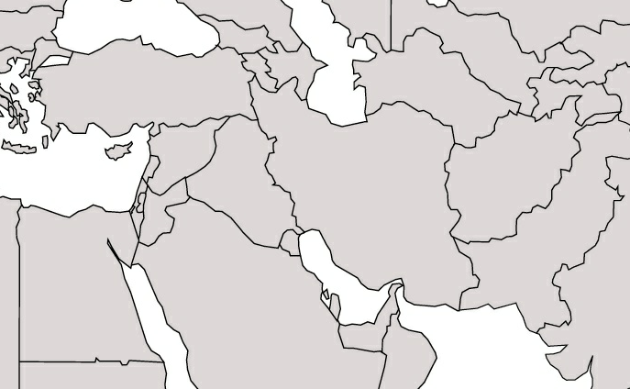

PERSIAN Summary. Put together the Political, Economic, Religious, Social, Interactive, Artistic, & Natural characteristics. This should be FULL of names, dates, key terms, & other historic evidence! Key terms for the Persian Empire: Cyrus the Great, Darius I, satraps, satrapies (you may have to look this up elsewhere), Persepolis, Royal Road, Anatolia, Marathon, Xerxes, Thermopylae, Plataea, Salamis, Zoroastrianism, Zoroaster, Zend Avesta, Ahuramazda, Angra Mainyu, monotheism

Political: Thesis sentence:

Economic: Thesis sentence:

Religious/Philosophical: Thesis sentence:

Social: Thesis sentence:
Interactions Thesis sentence:

Arts/Intellectual Achievements: Thesis sentence:

Nature: Thesis sentence:

Thematic paragraph:

