Civilization Fact Report: Classical India (Mauryan and Guptan Empires)
Chronology. | Map.  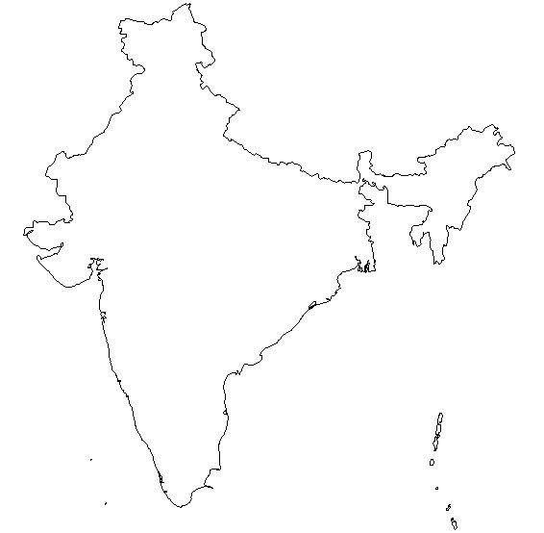

PERSIAN Summary. Put together the Political, Economic, Religious, Social, Interactive, Artistic, & Natural characteristics. This should be FULL of names, dates, key terms, & other historic evidence! Key terms for Classical India: Buddhism, Hinduism, Siddhartha Gautama, Buddha, Ganges River, Ashoka, Mauryan Dynasty, Chandragupta Maurya, Magadha, Battle of Kalinga, Gupta Empire, Chandra Gupta, Indian Ocean Maritime System, 3 legs of Indian Ocean Maritime System, lateen sail, monsoon winds, nirvana, Four Noble Truths, Eightfold Path, Theravada, Mahayana, boddhisatva

Political: Thesis sentence:

Economic: Thesis sentence:

Religious/Philosophical: Thesis sentence:

Social: Thesis sentence:
Interactions Thesis sentence:

Arts/Intellectual Achievements: Thesis sentence:

Nature: Thesis sentence:

Thematic paragraph:

