Civilization Fact Report: Classical Greece and Alexander the Great
Chronology. | Map.  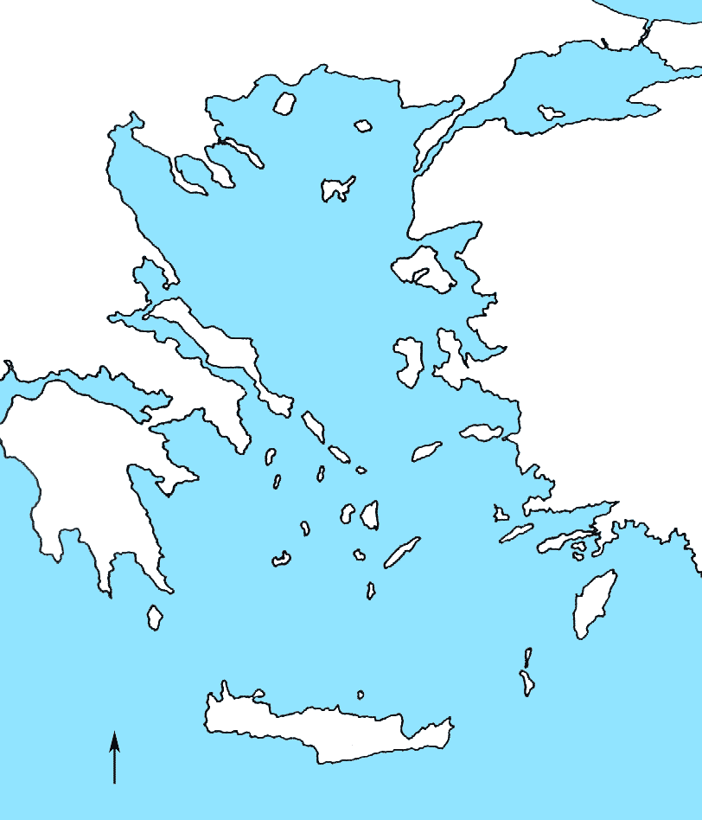  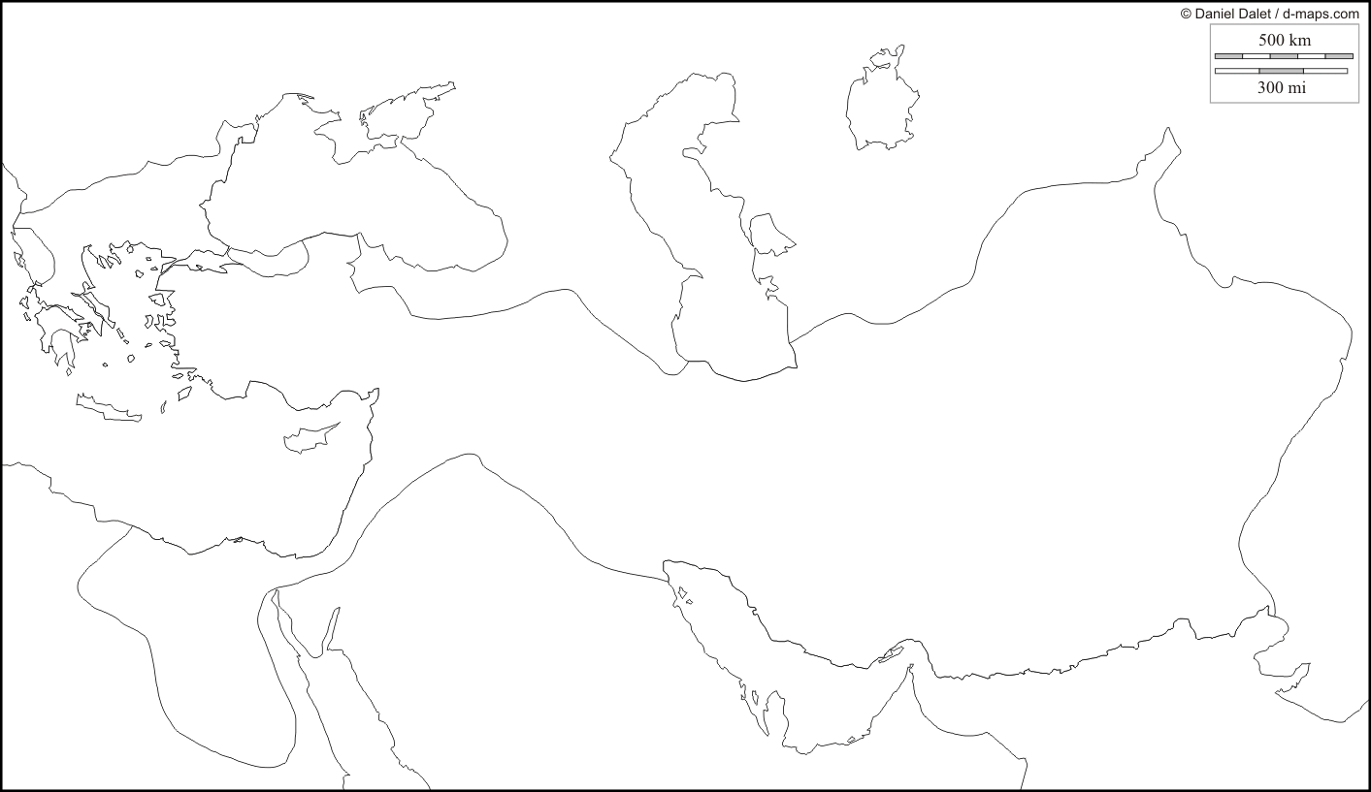

PERSIAN Summary. Put together the Political, Economic, Religious, Social, Interactive, Artistic, & Natural characteristics. This should be FULL of names, dates, key terms, & other historic evidence! Key terms for Classical Greece and Alexander the Great: Phoenicians, polis, poleis, oligarchies, monarchies, aristocracies, democracies, tyrants, Athens, Sparta, Solon, Cleisthenes, phonetic alphabet, Council of 500, Messenia, helots, Ionia, coins, hoplites, colonies, Marsalia, Magna Graecia (you’ll need to look elsewhere for this), secularism, philosophy, natural law, Socrates, Plato, Aristotle, drama, lyric poetry, classical architecture, Acropolis, Hellenic culture, Marathon, Darius I, Xerxes, Delian League, Pericles, Peloponnesian War, Macedon, Philip II, Alexander the Great, Gaugamela (you’ll need to look elsewhere for this), Hellenistic Age, Antigonus, Ptolemy, Seleucus, Hellenistic synthesis, Bactria

Political: Thesis sentence:

Economic: Thesis sentence:

Religious/Philosophical: Thesis sentence:

Social: Thesis sentence:
Interactions Thesis sentence:

Arts/Intellectual Achievements: Thesis sentence:

Nature: Thesis sentence:

Thematic paragraph:

