Civilization Fact Report: Classical China (Qin & Han Dynasties)
Chronology. | Map.  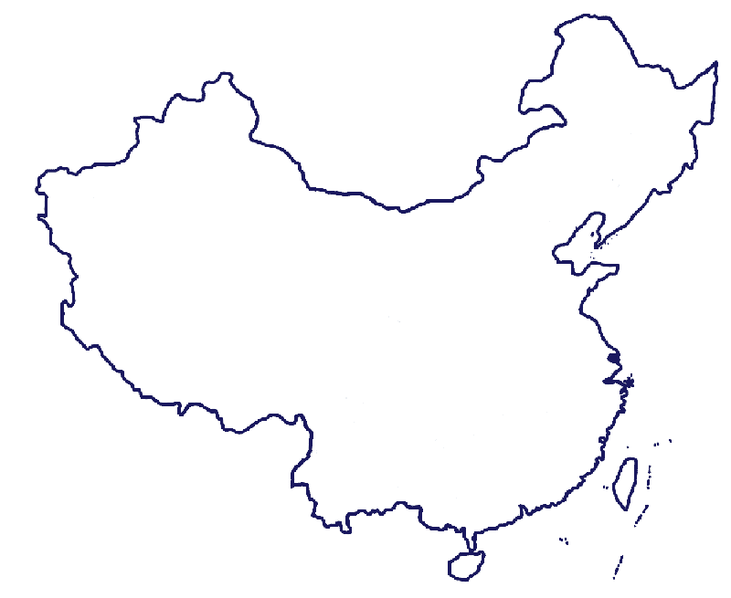

PERSIAN Summary. Put together the Political, Economic, Religious, Social, Interactive, Artistic, & Natural characteristics. This should be FULL of names, dates, key terms, & other historic evidence! Key terms for Classical China: Warring States Period, Zhou Dynasty, Legalism, Daoism, Laozi, Dao, Confucianism, Confucius, Analects, Book of Changes, Book of History, Book of Etiquette, Book of Songs, reciprocity, Xiao, Ren, Li, Mencius, Xunzi, Qin Dynasty, Shi Huangdi, Xi’an, Great Wall, administrative provinces, Shang Chinese script, Terra Cotta Army, Han Dynasty, Liu Bang, mandate of heaven, Han Wudi, nomadic groups, Korea, forbidden city, shi, examinations, University at Xi’an, scholar-gentry, Ordinary citizens, underclass, brush pen, paper, water mills, rudders, compasses, Silk Road, calligraphy, acupuncture, nomadic invasions, dynastic cycle, Zhang Jian, silk, ‘heavenly horses,’ stirrup, Tarim Basin, Indian Ocean Maritime System

Political: Thesis sentence:

Economic: Thesis sentence:

Religious/Philosophical: Thesis sentence:

Social: Thesis sentence:
Interactions Thesis sentence:

Arts/Intellectual Achievements: Thesis sentence:

Nature: Thesis sentence:

Thematic paragraph:

