Civilization Fact Report: Ancient South Asia
Chronology. | Map.  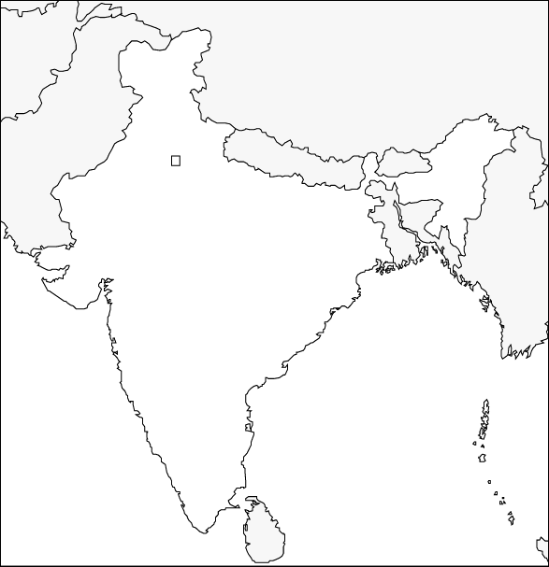

PERSIAN Summary. Put together the Political, Economic, Religious, Social, Interactive, Artistic, & Natural characteristics. This should be FULL of names, dates, key terms, & other historic evidence! Key terms for Ancient South Asia: Indus River Valley, Mohenjo-Daro, Harappa, Dravidian, Aryans, monsoon rains, Hindu Kush Mountains, systems failure, caste system, varna, jati, Brahmins, Kshatriya, Vaishya, Shudra, Vedas, Vedic Age, Rig Veda, Upanishads, reincarnation, atman, Hinduism, karma, dharma, moksha, Vishnu, Shiva, mudras, Mahabharata, Ramayana, Bhagavad-Gita

Political: Thesis sentence:

Economic: Thesis sentence:

Religious/Philosophical: Thesis sentence:

Social: Thesis sentence:
Interactions Thesis sentence:

Arts/Intellectual Achievements: Thesis sentence:

Nature: Thesis sentence:

Thematic paragraph:

