Civilization Fact Report: Ancient Mesopotamia
Chronology. | Map.  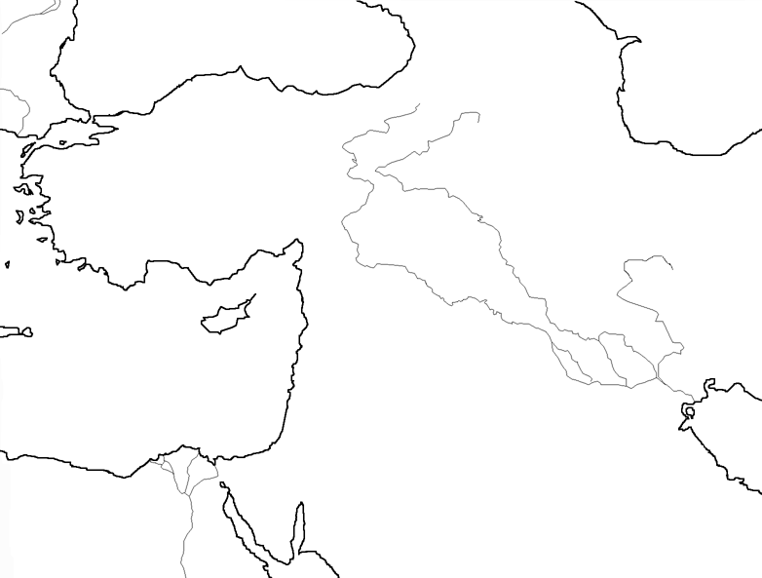

PERSIAN Summary. Put together the Political, Economic, Religious, Social, Interactive, Artistic, & Natural characteristics. This should be FULL of names, dates, key terms, & other historic evidence! Key terms for Ancient Mesopotamia: Mesopotamia, Semitic, Sumerians, city-states, labor systems, Sargon, Akkadian Empire, Akkad, cultural diffusion, Fertile Crescent, theocracies, Ur, Hammurabi, Babylonians, Hittites, Assyrians, New Babylonians, law code, Hammurabi’s Code, cuneiform, Epic of Gilgamesh, Uruk, ziggurats, amulets, Late Bronze Age, cosmopolitanism, Hebrew Bible, Judaism, Ssaul, David, Solomon, Abraham, diaspora, monotheism, covenant

Political: Thesis sentence:

Economic: Thesis sentence:

Religious/Philosophical: Thesis sentence:

Social: Thesis sentence:
Interactions Thesis sentence:

Arts/Intellectual Achievements: Thesis sentence:

Nature: Thesis sentence:

Thematic paragraph:

