Civilization Fact Report: Ancient Egypt
Chronology. | Map.  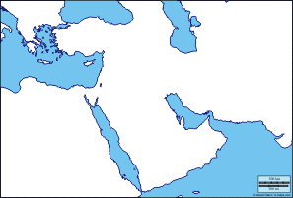

PERSIAN Summary. Put together the Political, Economic, Religious, Social, Interactive, Artistic, & Natural characteristics. This should be FULL of names, dates, key terms, & other historic evidence! Key terms for Ancient Egypt: Nile River, cataracts, flooding, bronze, Hyksos, iron, pharaoh, Menes, Horus, ma’at, bureaucrats, Old Kingdom, Middle Kingdom, New Kingdom, social mobility, patriarchy, Hatshepsut, pyramids, hieroglyphics, pictographs, papyrus, Amon-Re, Isis, Osiris, Horus, The Book of the Dead,

Political: Thesis sentence:

Economic: Thesis sentence:

Religious/Philosophical: Thesis sentence:

Social: Thesis sentence:
Interactions Thesis sentence:

Arts/Intellectual Achievements: Thesis sentence:

Nature: Thesis sentence:

Thematic paragraph:

